Exposure Visit of Scientist, Students, Farmers at ICFRE-IFP, Ranchi & its sub centres under Extension Division
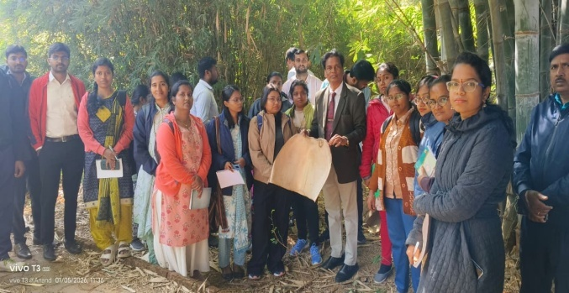 | 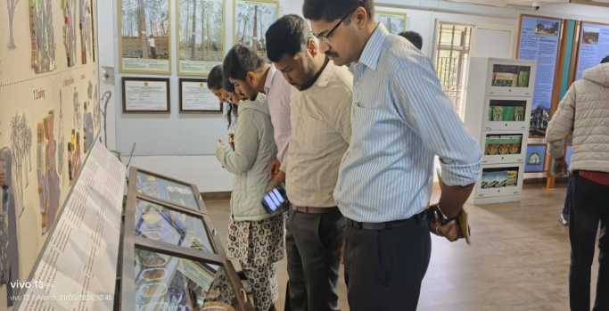
Visit of Newly appointed Scientists of CTRTI, Ranchi and APs of Sai Nath University
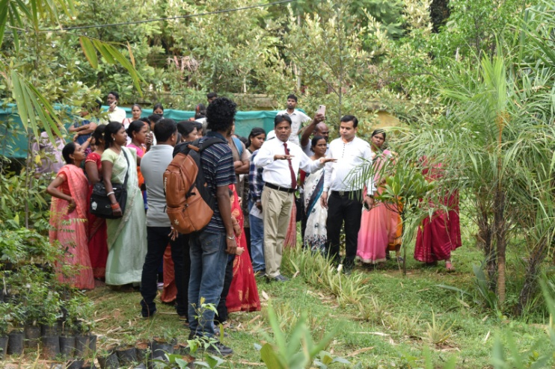 | 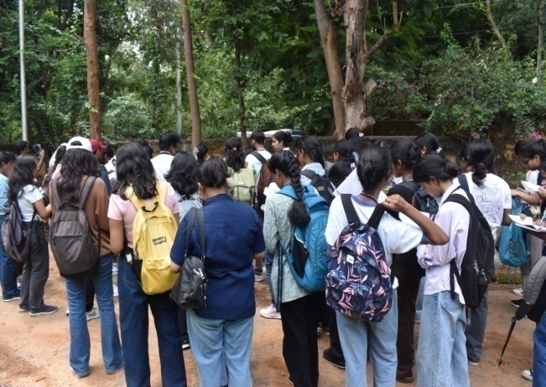
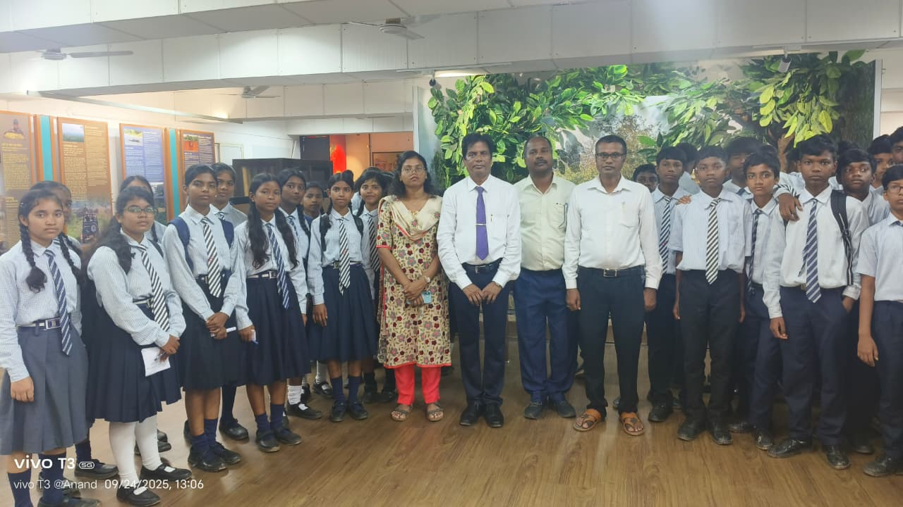 | 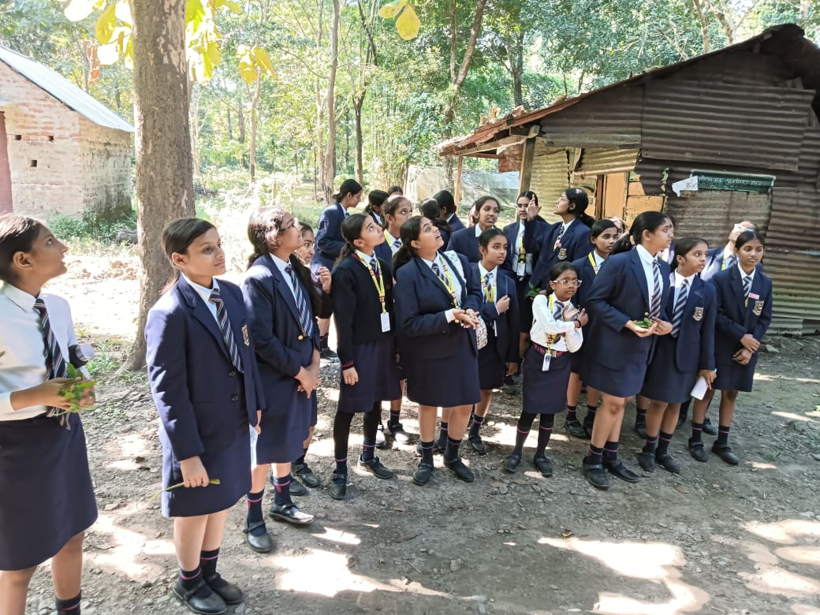
Visit of students from different colleges & Schools at ICFRE-IFP, Ranchi & its sub centre

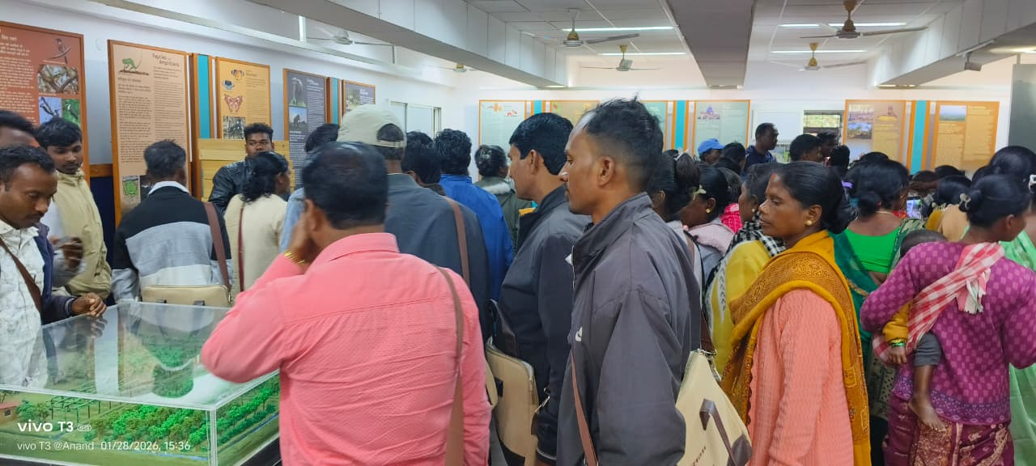 |  | 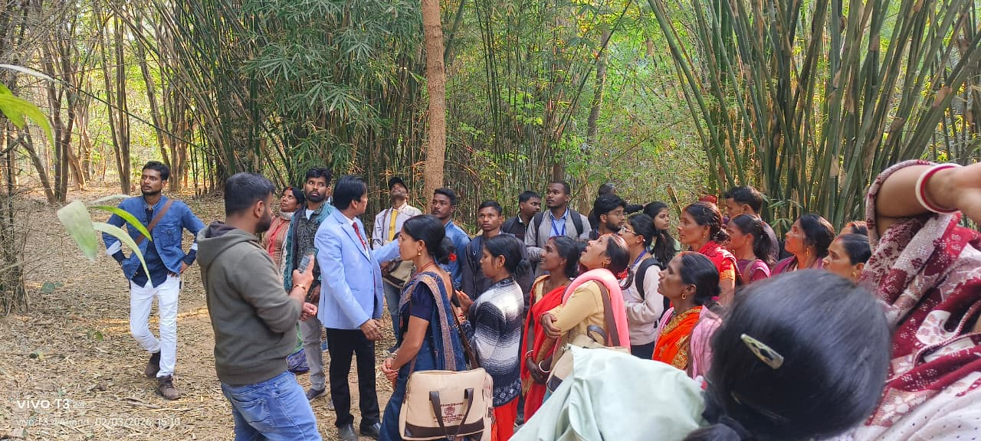
Exposure visit of Farmers of different villages of Jharkhand
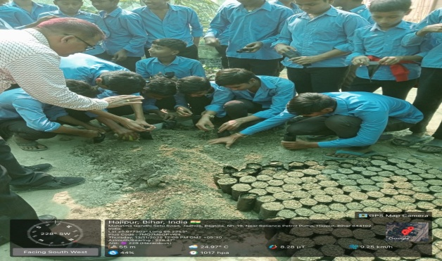 |  | 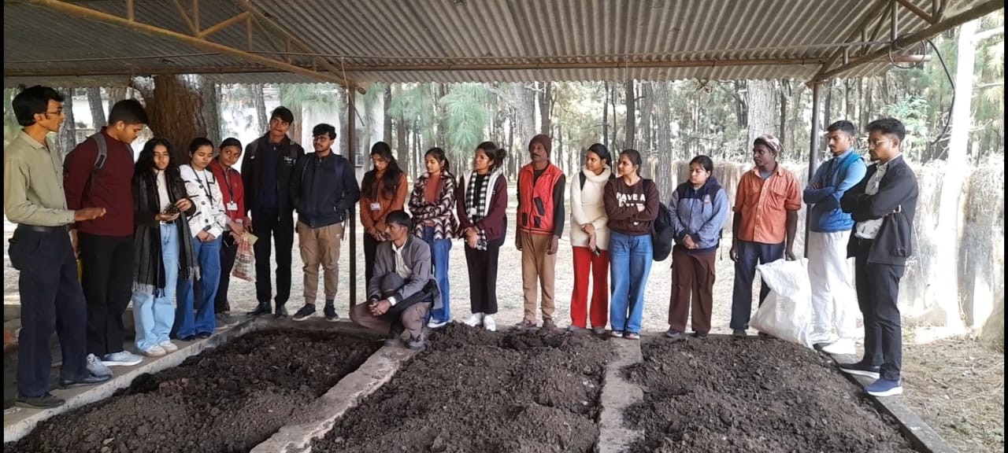
Students visit at Jadua & Mandar sub centre of ICFRE-IFP, Ranchi under Prakriti program
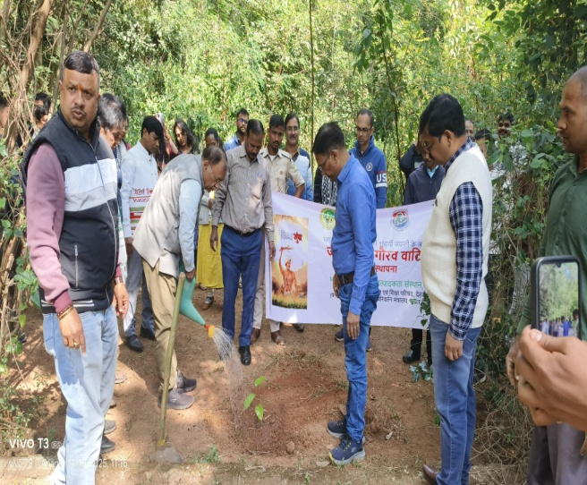 | 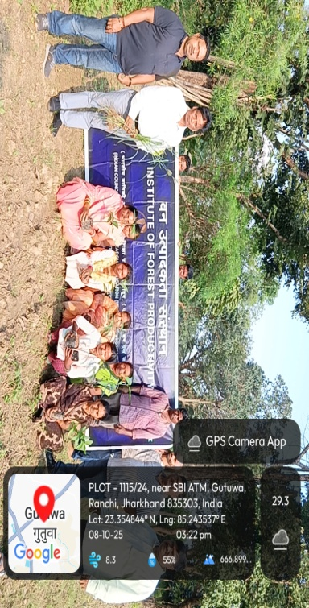
Programs organized by ICFRE-IFP, Ranchi during Poshan saptah and Janjatiya Gaurav diwas

TREE GROWERS MELA
Organized under the supervision of the ICFRE- Institute of Forest Productivity , Ranchi.
- Sessions on climate resilience and soil conservation
- Participation: tribal farmers, women SHGs, forest officials
- Trainings and Demonstrations emphasizing nursery management, agroforestry, organic pest control and biodiversity-friendly practices. Focus on medicinal & aromatic plants alongside timber and multi-use species.
- Promotion of agroforestry and indigenous species
- Youth and women engagement for income-generating activities
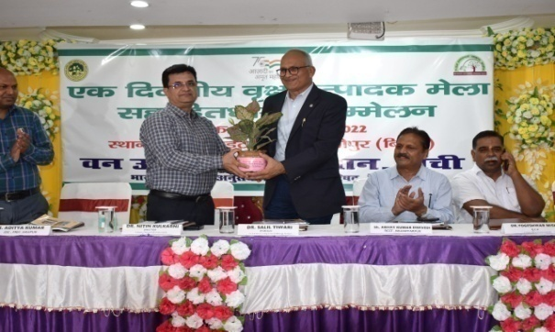 |  | 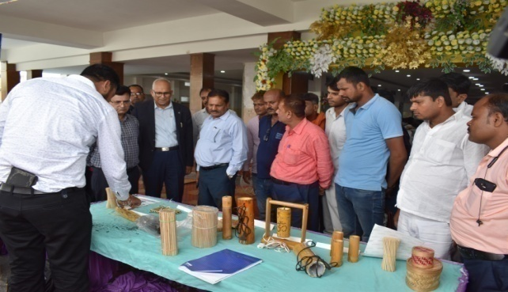
Tree Growers Mela cum stakeholder meet at Hajipur, Bihar on 21st September 2022
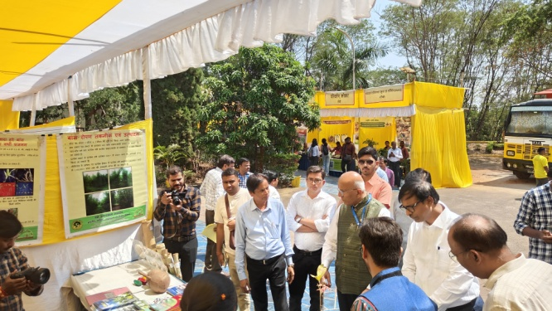 |  | 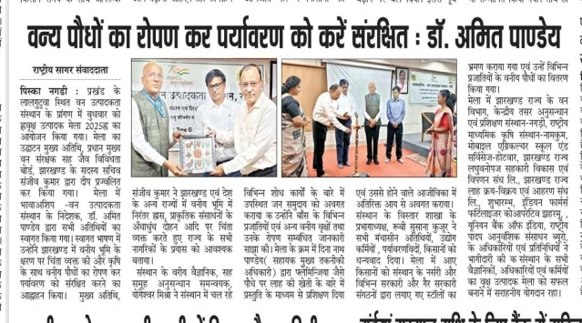
Tree Growers Mela at ICFRE-IFP, Ranchi on 19th March 2025
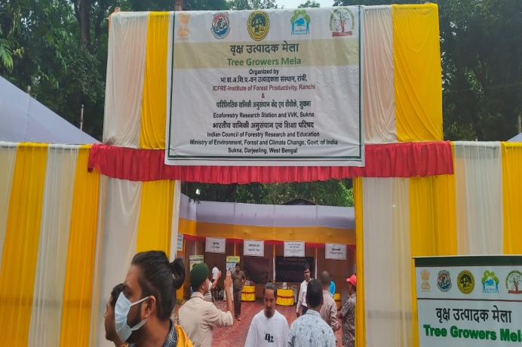 |  | 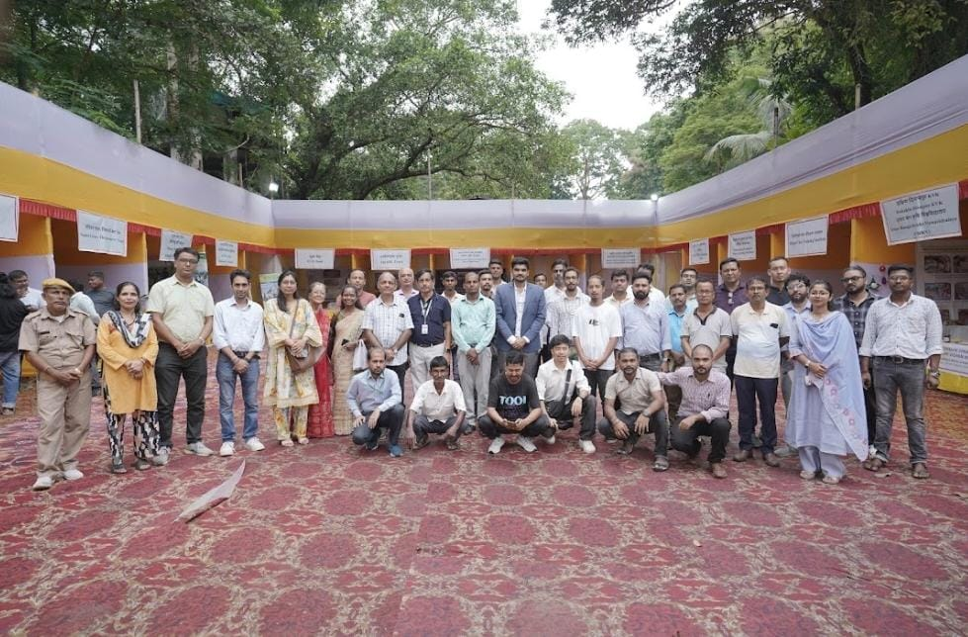
Tree Growers Mela at Sukna, Siliguri, West Begal on 10th September 2025
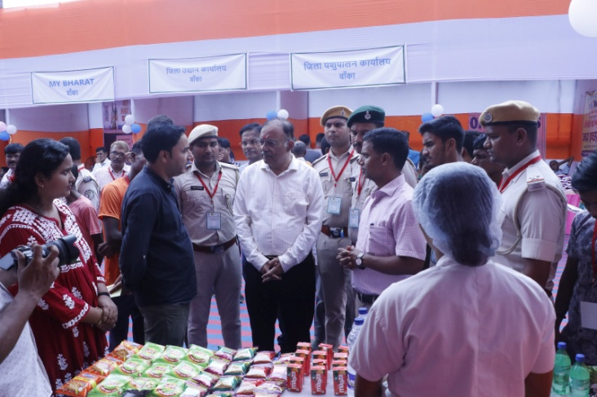 |  | 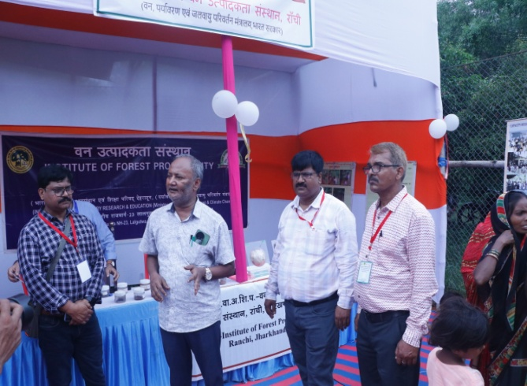
Tree Growers Mela at Supaha, Banka, Bihar on 18th September 2025
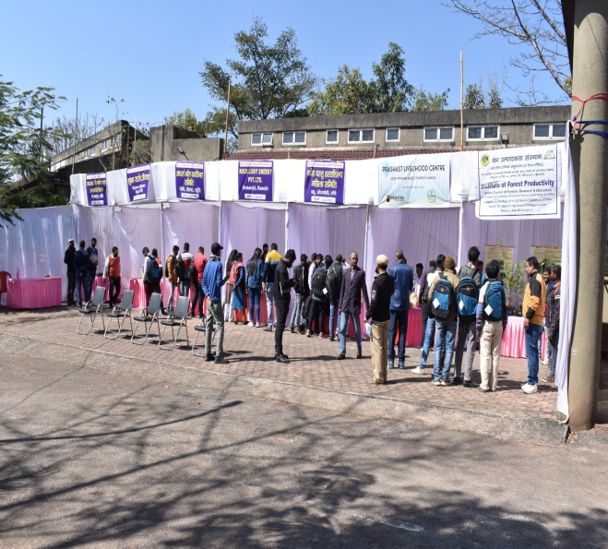 | 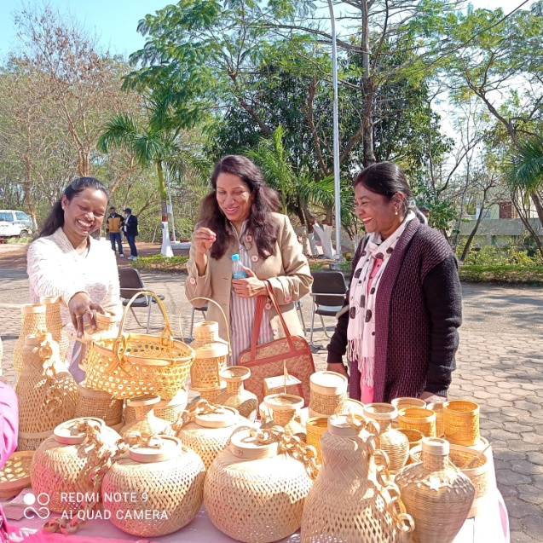
Bamboo Producer cum stakeholder meet under Tree Growers Mela at ICFRE-IFP, Ranchi on 14th February 2022

Van Vigyan Kendra
A network of field centres delivering forestry training and quality planting materials to support sustainable livelihoods and ecological restoration across Jharkhand, Bihar and West Bengal.
Established by ICFRE under CAMPA (MoEF&CC), VVKs aim to bridge the gap between forestry research and field implementation. They translate scientific research into practical, field-ready technologies for ecological restoration, afforestation, and livelihood enhancement. These centers also focus on capacity building, demonstration of improved practices, and promoting sustainable forest-based income opportunities for rural communities.
The major stakeholders include farmers, tribal communities, forest departments, research institutes, and rural youth entrepreneurs. These groups actively participate in training, demonstrations, and implementation of forestry-based livelihood activities.Their collaboration ensures better knowledge transfer, community participation, and long-term sustainability of forest and agroforestry initiatives..
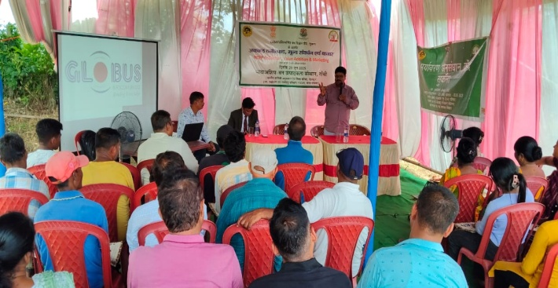 | 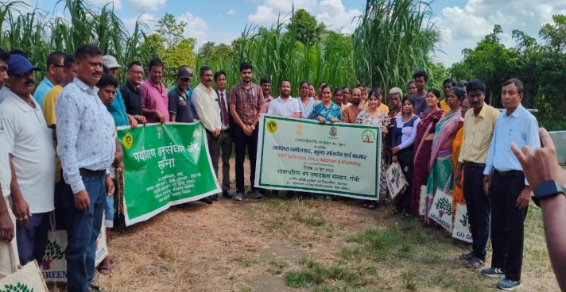
Training program under VVK, Sukna, Siliguri, West Bengal
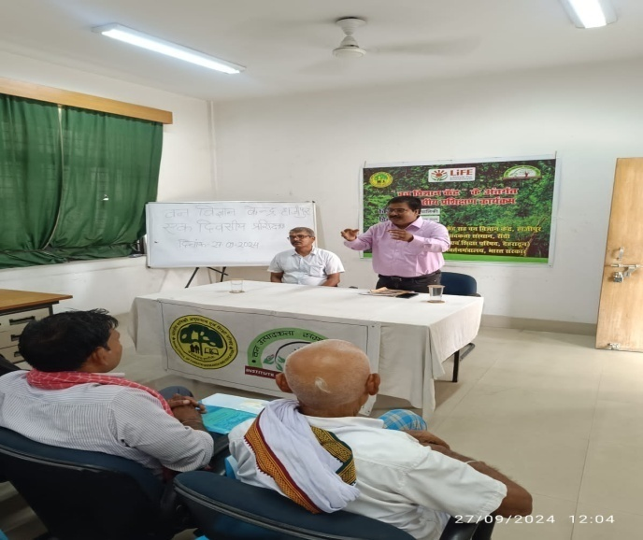 | 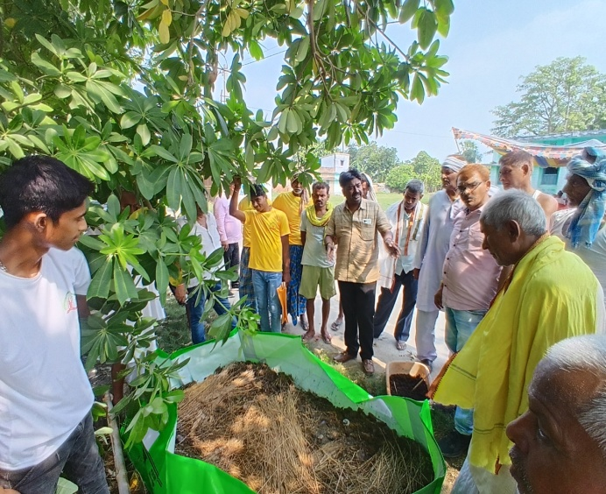
Training program under VVK, Jadua, Hajipur, Bihar
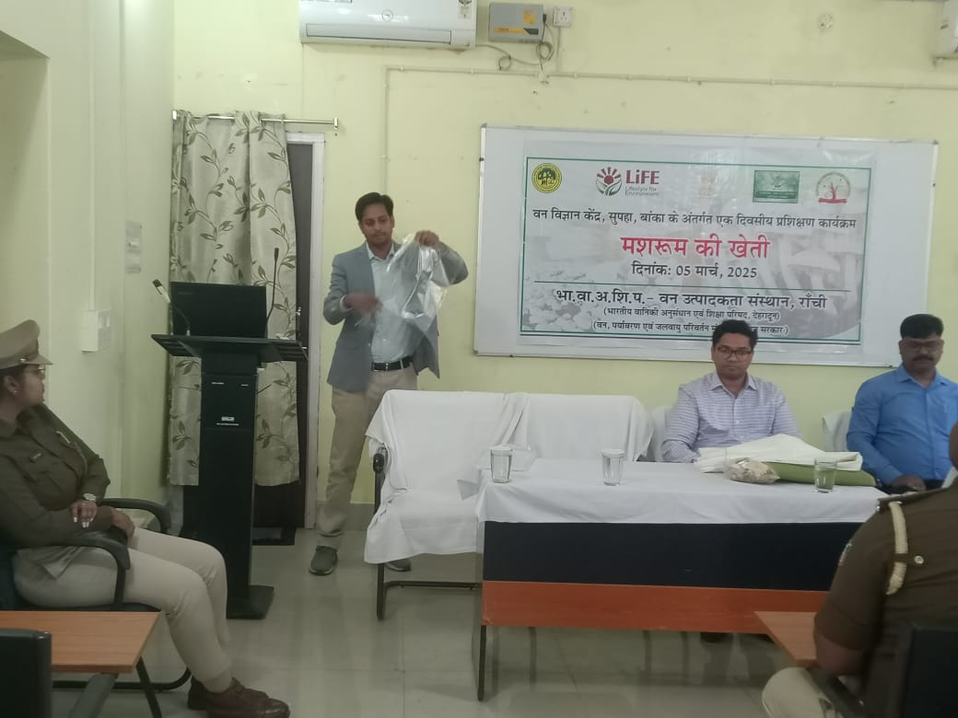 | 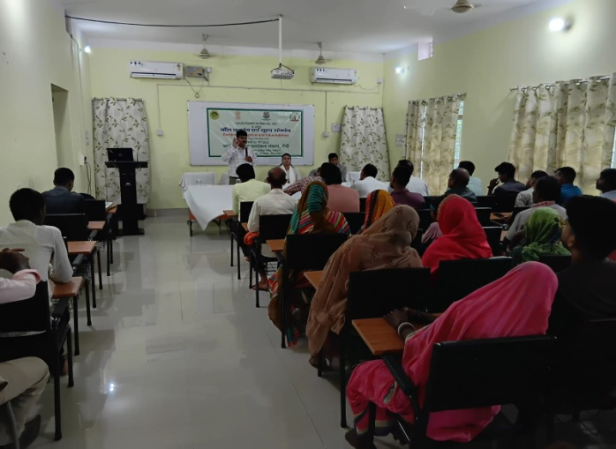
Training program under VVK, Jadua, Hajipur, Bihar
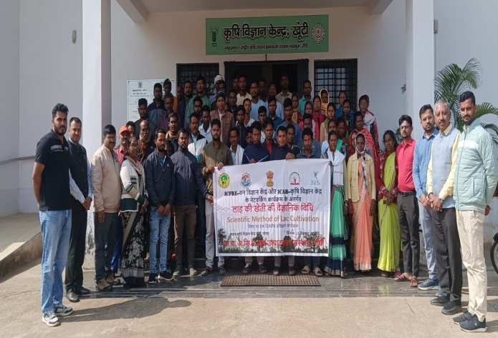 | 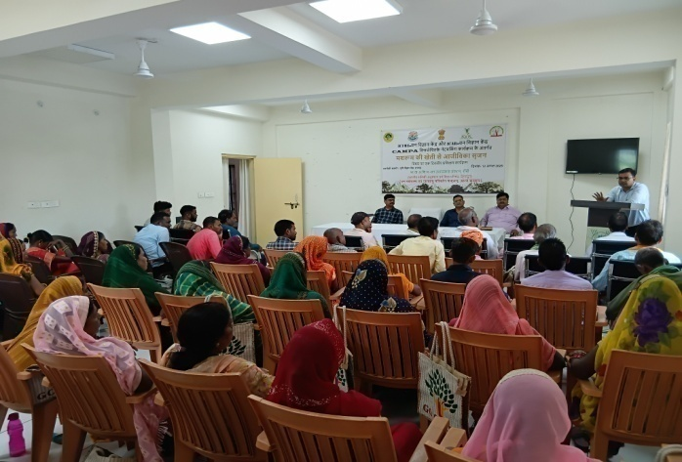
Training program under networking VVK-KVK at KVK, Khunti | Training program under networking VVK-KVK at KVK, Mandu, Ramgarh

Demo Village
The Demo Village concept was initiated by the Indian Council of Forestry Research and Education (ICFRE) to effectively disseminate forestry-based technologies developed by ICFRE and its institutes to end users, particularly farming communities.
At ICFRE-Institute of Forest Productivity (IFP), Ranchi, the Demo Village serves as a model for sustainable rural development rooted in environmentally responsible practices.
Implemented in active collaboration with forestry extension programs, it aims to build resilient village communities by enhancing their skills, awareness, and capacity to address challenges related to natural resource depletion, climate change, and environmental sustainability.
The initiative showcases practical, replicable solutions for agroforestry, soil and water conservation, livelihood enhancement, and climate-resilient farming practices, empowering local communities as active stakeholders in sustainable development.

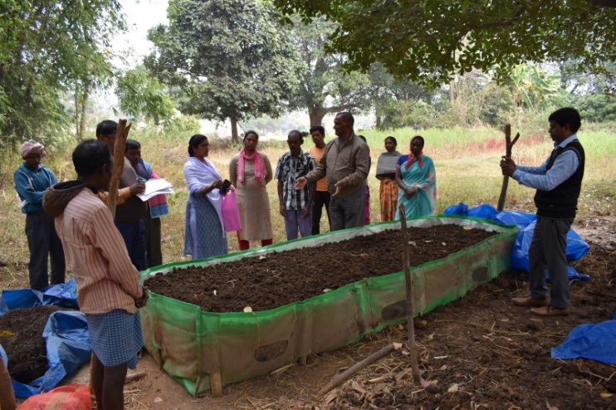 | 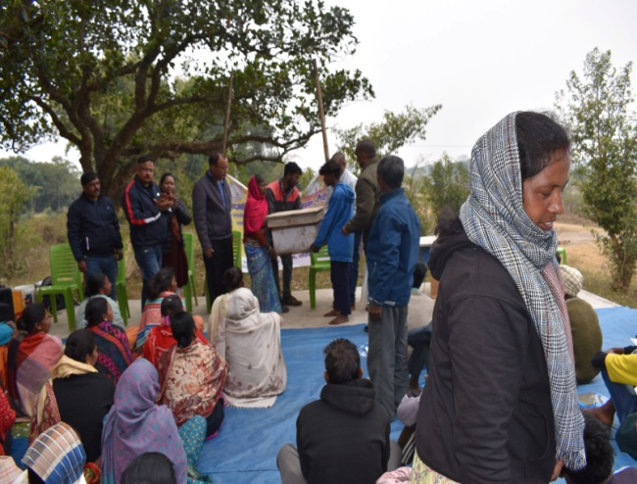
Demo Village Kutam, Khunti

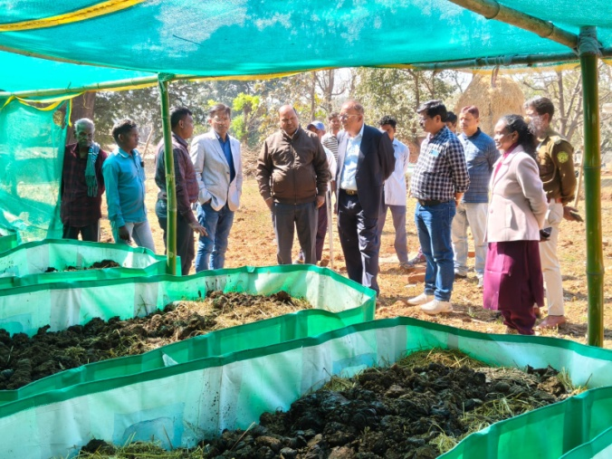 | 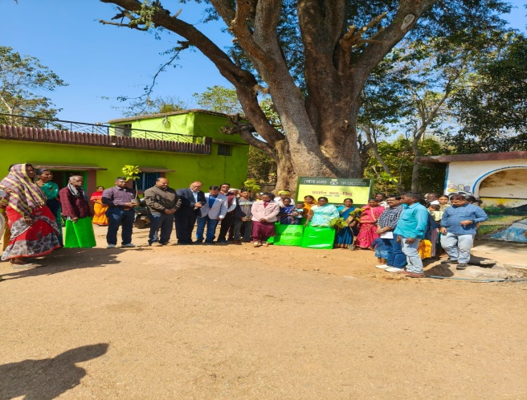
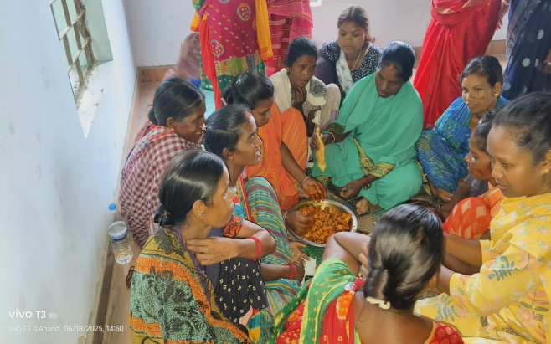 | 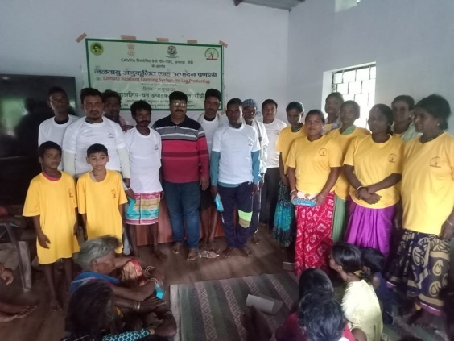
Demo Village Jidu, Angara, Ranchi

Demonstration plot of Melia at Demo village Kutam, Torpa, Khunti, Jharkhand
